Table of Contents

1. Introduction

**1.1 Purpose 2**

**1.2 Document Conventions 2**

**1.3 Intended Audience and Reading Suggestions 2**

**1.4 Product Scope 2**

**1.5 References 2**

**2. Overall Description**

**2.1 Product Perspective 3**

**2.2 Product Functions 5**

**2.3 User Classes and Characteristics 6**

**2.4 Operating Environment 7**

**2.5 Design and Implementation Constraints 8**

**2.6 User Documentation 9**

**3. System Features 10**

**4. External Interface Requirements**

**4.1 User Interfaces 11**

**4.2 Hardware Interfaces 11**

**4.3 Software Interfaces 11**

**4.4 Communications Interfaces 11**

**5. Other Nonfunctional Requirements**

**5.1 Performance Requirements 12**

**5.2 Safety Requirements 13**

**5.3 Security Requirements 13**

**5.4 Software Quality Attributes 13**

**1. Introduction**

* 1. **PURPOSE**

The purpose of this document is to build a Document Management System (DMS) for archiving, and digitalized any kind of physical documents. In order to give maximum benefit to the client, any file and folder add, delete, update to share, search and integration with other software by Application Programming Interface (**API)**.

**1.2 DOCUMENT CONVENTIONS**

This document uses the following conventions.

|  |  |
| --- | --- |
| Interface Design | Front End Design |
| Flow Char | Software Process Flow Chart |
| Use Case | Use Case Diagram |
| ERD | Entity Relationship |
| DB | Database |

**1.3 Intended Audience and Reading Suggestions**

This software is a prototype for the Document management system (DMS). This will be implemented under the guidance of Saffron Corporation Managing Director and System Analyst. This software is useful for the Document Archiving, Finding, Searching, sharing, updating, document Security and as well as to the store any kind of file like audio video and FTP file system. It will have internal external **API** facility.

**1.4 Project Scope**

The purpose of the Document Management System (DMS) is to ease document Management and to create user group to handle documents based on type as per the location or branch office with strong security, easy-to-use software for clients, upload documents, share documents. store file and folder with FTP System. Above all, we hope to provide a comfortable user experience along with the best pricing available.

**1.5 References**

<https://www.saffroncorporation.com.bd/projects/dms>

*Click This Link for Document Management System (DMS) demo and other development needs.*

**2. Overall Description**

**2.1 Product Perspective**

A Document Management System database system stores the following information.

**Admin User Details:**

It includes username, password, mobile number, email, etc.

**Local Users Details:**

It includes username, password, mobile number, email, user type, etc.

**User Registration Details:**

It includes full name Bangla and English, fathers name Bangla and English, mothers name Bangla and English, date of birth, nid, birth certificate, passport, gender, religion, blood group, marital status, mobile, other mobile, username, password, user pic title, user pic directory, etc.

**Groups:**

It includes group name, group desc, user id fix, status, etc.

**Group Users:**

It includes group user id fix, user id fix, status, etc.

**Updates:**

It includes update, user id fix, created, group id fix, etc.

**Branch Details:**

It includes branch name, branch address, branch head name, branch head mobile, reason for add branch, branch add date, branch document type, branch technical person, branch mobile, branch email, branch other number, tracking number, etc.

**Branch Rules:**

It includes branch active id, branch deactivate id, branch temporary id, branch rules details, branch pending id, branch rules logs, etc.

**Document files Details:**

It includes file id, file title, file format, file categories, file details, etc.

**Document folder details:**

It includes folder id, folder title, folder categories, folder details, etc.

**Documents Categories Details:**

It includes doc categories id, categories 1, categories 2, categories 3, categories 4, categories 5, etc.

**Document Release Record Details:**

It includes doc release id, doc released date, doc released time, doc release total, etc.

**Document unrelease Record Details:**

It includes doc unrelease id, doc unreleased date, doc unreleased time, doc unrelease total, etc.

**Document Archiving Record Details:**

It includes doc archive id, doc archived date, doc archived time, doc archive total, etc.

**Messages Details:**

It includes message id, message subject, message body content, message sender name, message receiver name, date and time, message logs, etc.

**Report Details:**

It includes report id, report from date and time, report to date and time, report title, report details, report reason, report person, etc.

**Settings Details:**

It includes settings id, settings type, setting date and time, authorized person, etc.

**Logs Details:**

It includes logs id, log from date and time, log to date and time, logs title, logs content, authorized person, etc.

**2.2 Product Features**

The major features of Document Management System database system as shown in below Use case Diagram

[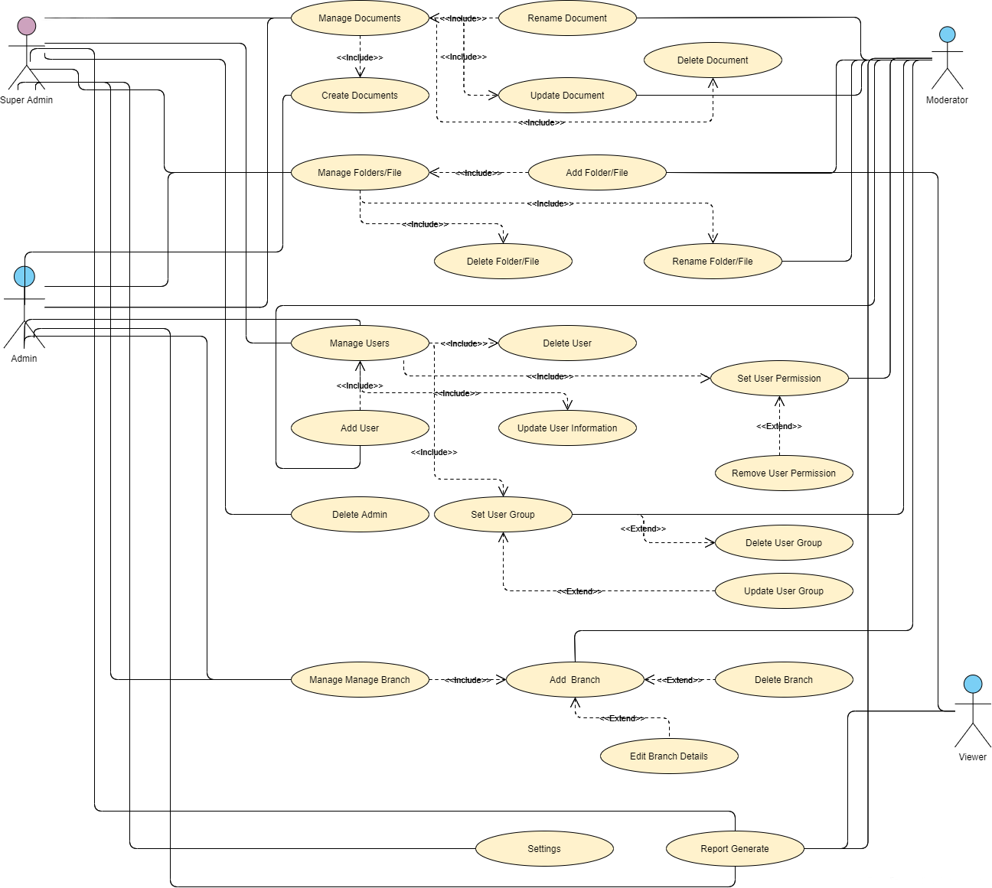](https://krazytech.com/projects/sample-software-requirements-specificationsrs-report-airline-database/attachment/ad-layout-of-airline-database-system)

**Fig: DMS Use Case Diagram**

**2.3 User Class and Characteristics**

Users of the system should be able to store any documents, files, folders and share them with other users as needed. And will be able to view, find and upload new documents at any time without limit. Also, can sorting the documents according to category. Unlimited users’ facility as well as user groups can be added, branches facility each branch will be an area or an office. The system will have internal and external API facility which is, specific features of this software allow access from third party software. The system will support four types of user privileges, Super Admin, Admin, Moderator and view. Viewer will have access to view functions, and the moderator will have access to Moderator function. and the Admin will have access to both moderator and view function. Super Admin will have access to all users privilege the system should be able to do the following functions:

**Viewer Function:**

* View documents
* Search documents
* Print report

**Moderator Function:**

* Add users.
* Add groups.
* Create folder
* Upload documents
* Download documents.

**Administration Function:**

* Add/Delete unlimited users.
* Add/Delete user groups.
* Add a new branch.
* Ensure user privilege permission.
* Upload Documents.
* Create/Remove folder.
* Provide Quota storage for users.
* Administrator can’t delete super admin

**Super Administration Function:**

* Add/Delete unlimited users.
* Add/Delete user groups.
* Add a new branch.
* Upload Documents.
* Ensure user privilege permission.
* Create/Remove folder.
* Provide Quota storage for users.
* Update system settings.

Make an Admin user

* User Name
* Password
* Email Address
* Flexible Date/time
* Confirmation

Add New Registration

* Full name
* Father’s name
* Mother’s name
* Date of birth
* NID
* Birth Certificate
* Passport Number
* Gender
* Religion
* Blood Group
* Marital Status
* Email Address
* Mobile Number
* Others Number
* User Name
* Password
* Confirm Password

Update User Information

This form same above user registration form.

Set User Permission

Select permission from dropdown

1. Admin
2. Moderator
3. Viewer etc.

Remove User

Remove User (Pop-Up alert set Yes or Not)

**2.4 Operating Environment**

Operating environment for Document Management system is as listed below.

* distributed database
* client/server system
* Operating system: Windows/Linux.
* database: MySQL, MariaDB database
* platform: HTML/CSS3/SASS/ JSON with Java /PHP/.Net

**2.5 Design and Implementation Constraints**

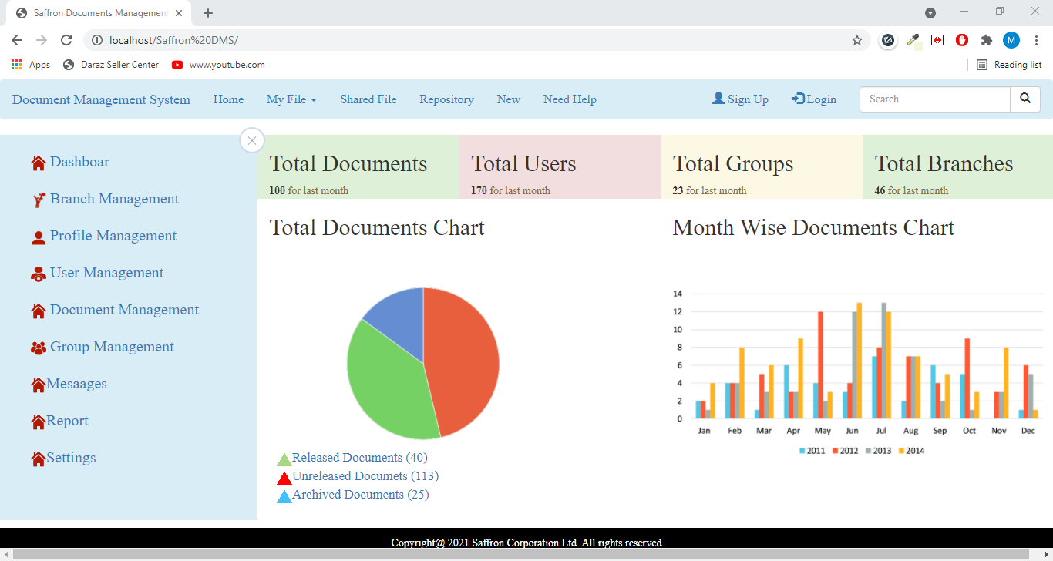

**Fig: DMS Dashboard**

**2.6 User Documentation**

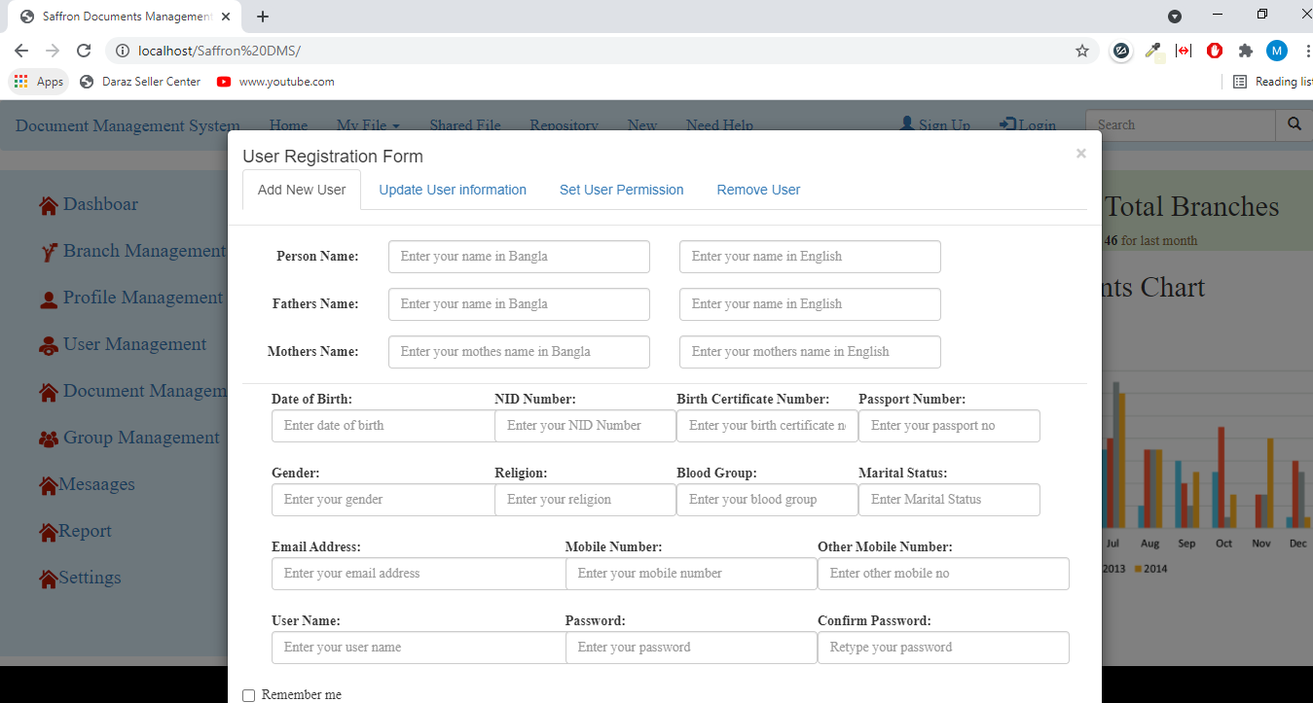

**Fig: DMS User Registration Form**

**3. System Features**

**Description and Priority**

The Document Management system maintains information on documents, file, folder, all users, all branches/location. Of course, this project has a high priority because it is very difficult to carry physical documents. In the future everything will be online, you can easily take advantages of wherever you are.

**Stimulus/Response Sequences**

* + Search for the document for edit, delete, update, share, etc.
  + View the documents like jpg, png, pdf, tft, audio, video on the software dashboard.

**Distributed Database:**

Distributed database implies that a single application should be able to operate transparently on data that is spread across a variety of different databases and connected by a communication network as shown in below figure.

[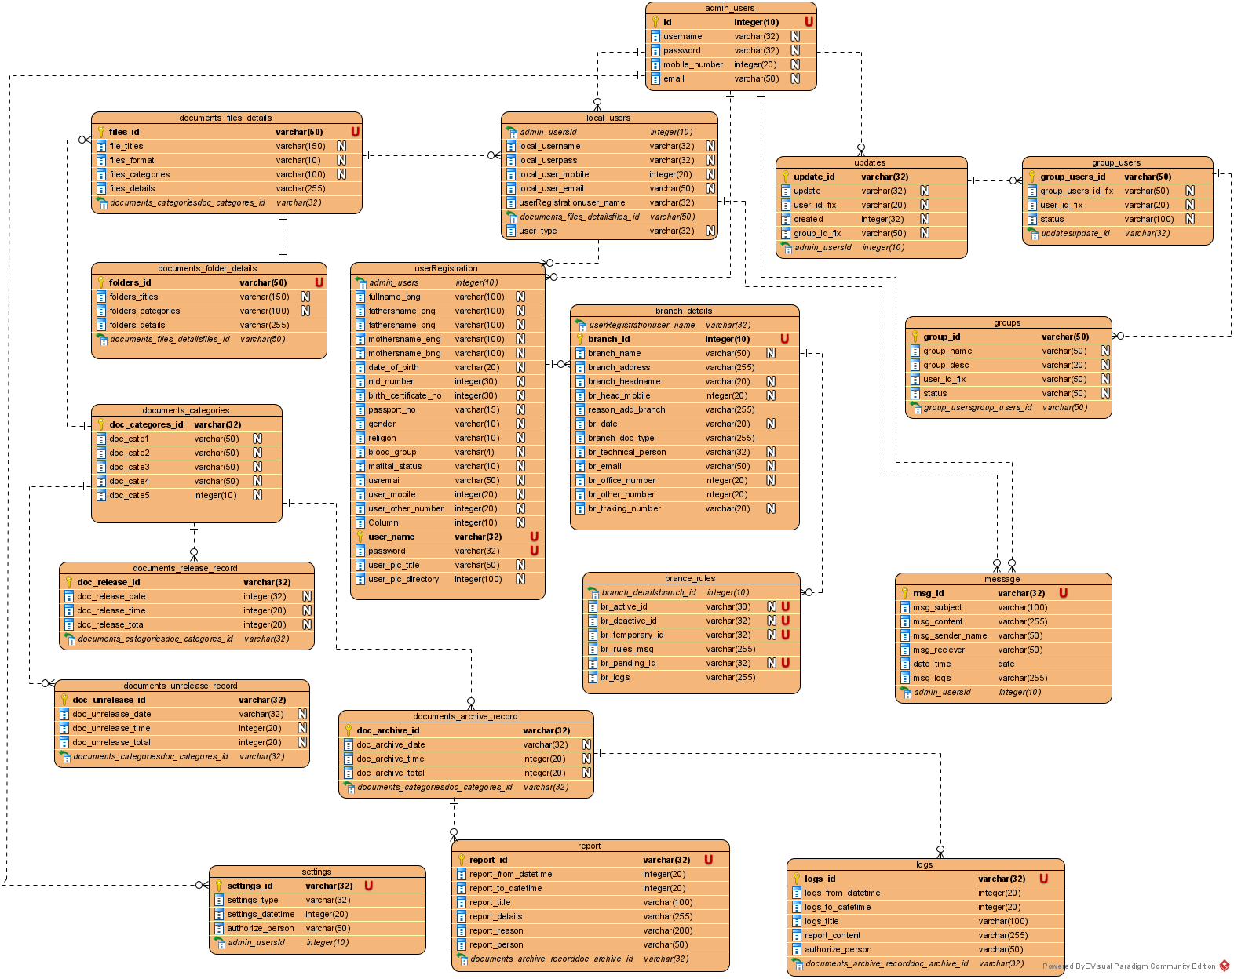](https://krazytech.com/projects/sample-software-requirements-specificationsrs-report-airline-database/attachment/ad-distributed-database-located-at-four-different-cities)

*The diagram shows the layout of Document Management system – entity–relationship model ERD*

**Client/Server System**

The term client/server refers primarily to an architecture or logical division of responsibilities, the client is the application (also known as the front-end), and the server is the DBMS (also known as the back-end).

A client/server system is a distributed system in which,

* Some sites are client sites and others are server sites.
* All the data resides at the server sites.
* All applications execute at the client sites.

**4. External Interface Requirements**

**4.1 User Interfaces**

* Front-end software development tools.
* Back-end software development tools.

**4.2 Hardware Interfaces**

* Windows 7-10
* Processor: Core i5 or higher
* RAM: 8GB
* Monitor: 24inch LED
* A browser which supports CGI, HTML & JavaScript.

**4.3 Software Interfaces**

Following are the software used for the Document Management System (DMS).

|  |  |
| --- | --- |
| **Software used** | **Description** |
| Operating system | We have chosen Windows and Linux operating system for its best support and user-friendliness. |
| Database | To save the DMS record we have chosen MySQL/MariaDB database. |
| PHP/ .Net | To implement the project, we have chosen PHP/ .Net language for its more interactive support. |

**4.4 Communication Interfaces**

This project supports all types of web browsers. We are using bootstrap 4 CSS and Grid System for easy responsive front-end UI system. There are using lots of modal Pop-up form for first loading the page to upload the Documents. It would be fully user-friendly interface system, etc.

**5. Nonfunctional Requirements**

**5.1 Performance Requirements**

The steps involved to perform the implementation of **DMS** database are as listed below.

**A) E-R Diagram**

The E-R Diagram constitutes a technique for representing the logical structure of a database in a pictorial manner. This analysis is then used to organize data as a relation, normalizing relation and finally obtaining a relation database.

* **ENTITIES:**Which specify distinct real-world items in an application.
* **PROPERTIES/ATTRIBUTES:** Which specify properties of an entity and relationships.
* **RELATIONSHIPS:** Which connect entities and represent meaningful dependencies between them.

[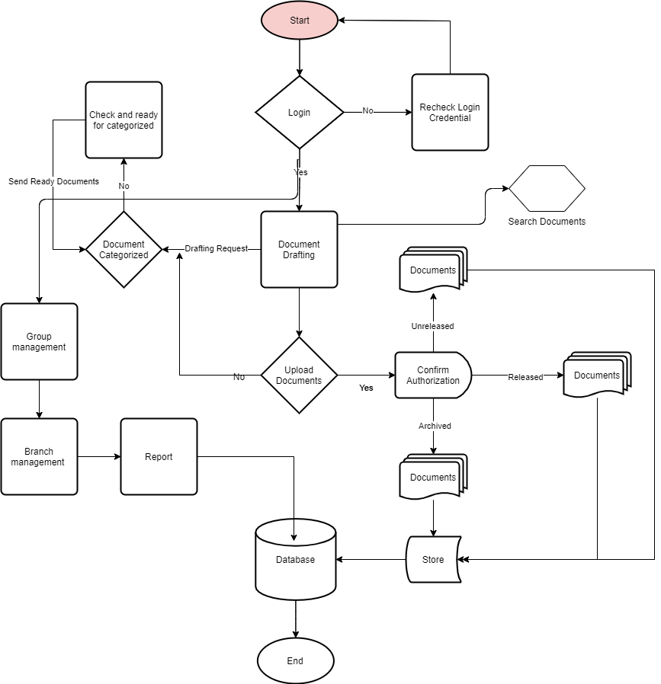](https://krazytech.com/projects/sample-software-requirements-specificationsrs-report-airline-database/attachment/ad-er-diagram-of-airline-database)

*the diagram shows the Process Flow Chart of DMS*

**B) Normalization:**

The basic objective of normalization is to reduce redundancy which means that information is to be stored only once. Storing information several times leads to wastage of storage space and increase in the total size of the data stored.

If a database is not properly designed it can give rise to modification anomalies. Modification anomalies arise when data is added to, changed or deleted from a database table. Similarly, in traditional databases as well as improperly designed relational databases, data redundancy can be a problem. These can be eliminated by normalizing a database.

Normalization is the process of breaking down a table into smaller tables. So that each table deals with a single theme. There are three different kinds of modifications of anomalies and formulated the first, second and third normal forms (3NF) is considered sufficient for most practical purposes. It should be considered only after a thorough analysis and complete understanding of its implications.

**5.2 Safety Requirements**

If there is extensive damage to a wide portion of the database due to catastrophic failure, such as a disk crash, the recovery method restores a past copy of the database that was backed up to archival storage (typically tape) and reconstructs a more current state by reapplying or redoing the operations of committed transactions from the backed-up log, up to the time of failure.

**5.3 Security Requirements**

Security systems need database storage just like many other applications. However, the special requirements of the security market mean that vendors must choose their database partner carefully.

**5.4 Software Quality Attributes**

* **Availability:**  Using this software, users will be able to archive their physical documents online and offline.
* **Correctness:** There is a high security system to store the correct documents safely.
* **Maintainability:** A system admin is required to manage databases and other system requirements from installation to use.
* **Usability:** The Document Management System (DMS) should satisfy a maximum number of customer’s needs.